We're going to have a look at some of the simple arithmetic covering addition, subtraction, division and multiplication.

So, let's say our program needs to add two numbers together. Each number is stored in its own unique variable and we want to store the result of the two numbers in a brand-new variable that we can call result.

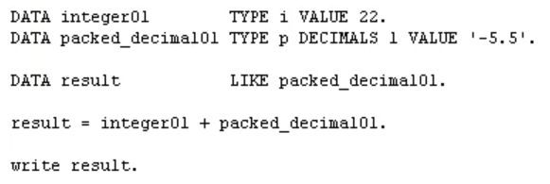



If result variable already held a number prior to the calculation taking place, it would then be overridden with the new result of the calculation.

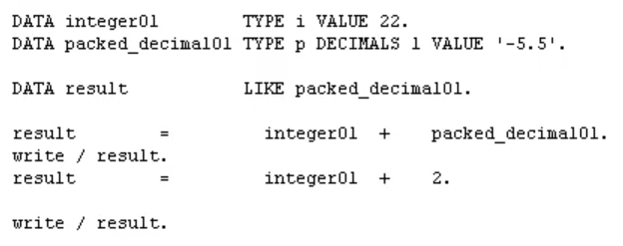

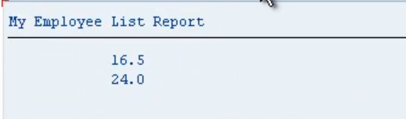

You'll also notice, I put space in front and behind the equal’s sign. You've always got to do this. And also, between the actual arithmetic operators as well. Always put space in front and behind. As your calculations become more complex, you'll start to use parenthesis. And you must ensure that you insert blank characters before and after the parenthesis to separate them from your arithmetic operators. Now when I say you've got to make sure you insert a space before and after, one space is the minimum.

You can, for instance, like I often do so I can line up my code and make it a lot more readable, you can insert as many spaces as you want. And it will all still work the same. And this allows us to define our calculations across many lines within the ABAP editor. Now as you can imagine, we're not just stuck to calculate in the value of variables we can. Also use individual values in our calculation, just as shown here. Shows an example. So, it's just output the result. Oops. There we go.